Relational schema (Task management application)

This document presents the relational schema of a task management application.

# Context:

The application allows users to manage their personal tasks by organizing them into their own unique repository and categories.

# Entity-relationship model:

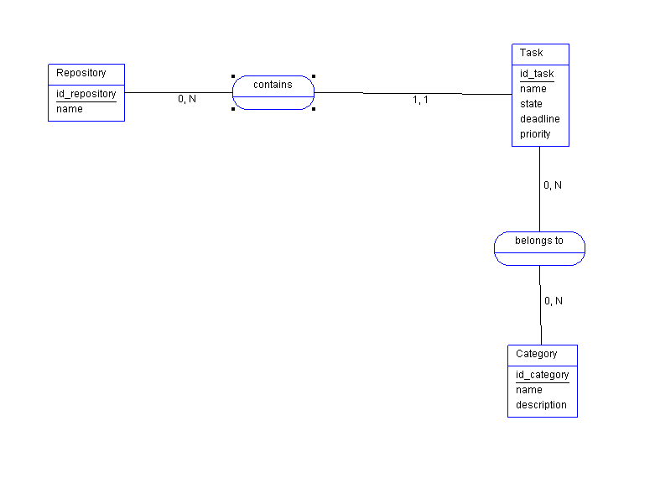

## Translation of the entity-association model into a relational schema:

Rule 1: each entity becomes a relation

Repository (id_repository, name)

Task (id_task, name, state, deadline, priority)

Category (id_category, name, description)

Rule 2:

Task (id_task, name, state, deadline, priority, #id_repository)

Rule 3:

belongsTo (#id_task, #id_category)